ASR 6070 Loaded Truck-in allow exception for intertransfer

Date: 2016.04.12

Allow loaded truck-in update with below prefix of container# : AAK

Purpose: inter-warehouse transfer

System Changes:

1. Code lookup – Listname = VWTRKINEXP.

Codelkup.Code = 1st 3 digit of Container #, to allow by-pass truck-in loaded validation. For those non-ocean inbound containers.

1. Truck-in for Loaded Container, add validation to allow by-pass container in the codelkup list.

Screen update:

1. System codelkup – VWTRKINEXP

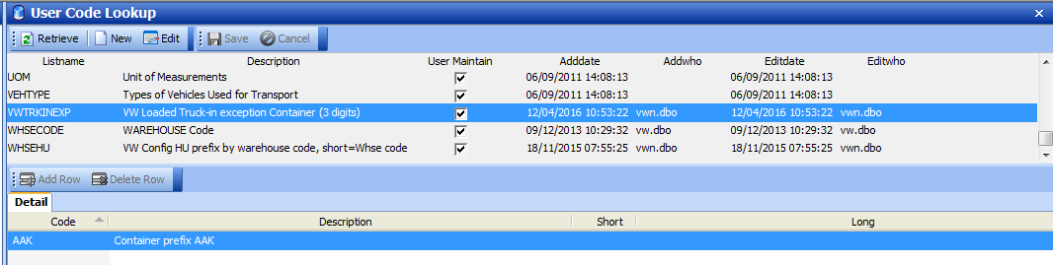

1. Truck-in Loaded Container – for non-ocean shipment, allow by-pass validation.

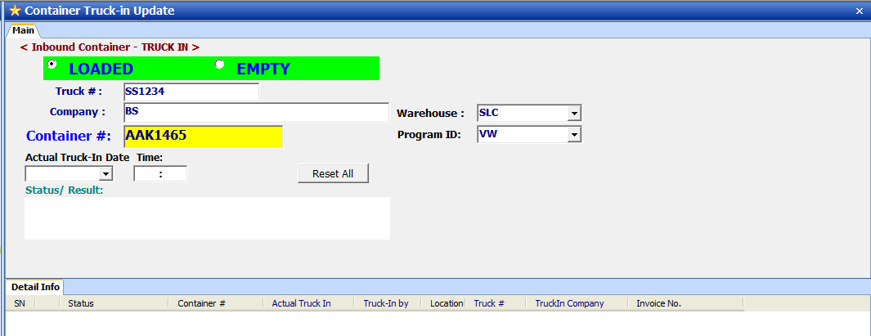

Truck in update successful.

